László Kürti
Rice University, Department of Chemistry, 6100 Main St., Houston TX 77005
Email: lk18@rice.edu
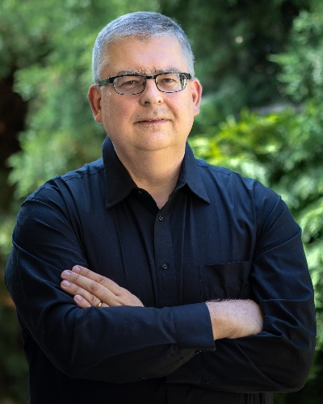
László was born and raised in Hungary. He received his Diploma from Lajos Kossuth University (now University of Debrecen) where he conducted research in the laboratory of Prof. Sándor Antus. Subsequently he received his M.Sc. at the University of Missouri-Columbia, working with Prof. Michael Harmata, and his Ph.D. degree (2006) in synthetic organic chemistry under the supervision of Prof. Amos B. Smith III at the University of Pennsylvania. In 2006 László joined the group of Prof. E.J. Corey at Harvard University. He began his independent career as an Assistant Professor in the Department of Biochemistry at UT Southwestern Medical Center, Dallas, Texas. In 2015 he joined the chemistry faculty at Rice University (Houston, Texas) where he is now a Full Professor. The Kürti group focuses on the development of powerful new methods for the expedient enantioselective assembly of highly functionalized biaryls, heterocycles and carbocycles.
Catalytic C-H Aminations, Cyclizations and Rearrangements: New Directions in the Synthesis of Nitrogen Heterocycles
N-heterocycles are present in more than 80% of active pharmaceutical ingredients (APIs) and agrochemicals.¹ In addition, many naturally occurring N-containing compounds show significant pharmacological and physiological properties. Despite their apparent abundance and importance, general and efficient synthetic approaches remain challenging. Therefore, there is a continuous need for the development of novel syntheses of N-containing compounds. In this talk, I will cover some of the most recent directions my group has taken towards the synthesis of N-heterocycles and C-H amination procedures: [1] a titanium-mediated synthesis of spirocyclic NH-azetidines²; [2] an unconventional approach to highly substituted aziridines: the aza-Quasi Favorskii reaction³; [3] a synthesis of N-activated α-bromo β-lactams from N-alkoxy silyl imino ethers⁴ and [4] a programmed synthesis of diverse N-heterocycles: an intramolecular catalytic C-H amination approach.

References:
[1] Jampilek, J. Molecules. 2019, 24, 3089. Njardarson, J.T. et al. J. Med. Chem. 2024, 67, 14, 11622–11655.
[2] Behnke, N., Lovato, K., Yousufuddin, M., Kürti, L. Angew. Chem. Int. Ed. 2019, 58, 14219.
[3, 4] Kattamuri, P.V., Zhao, J., Das, T.K., Siitonen, J.H., Morgan, N., Ess, D.H., Kürti, L. J. Am. Chem. Soc. 2022, 144, 10943. Rodriguez, Loch-Temzelides, Pandiri, Kirkland, Davenport, Ess, Kürti et al. Chem. Sci. Advance Article 2024.

